24ADI306 - DEEP LEARNING
ASSIGNMENT - 3
Comparative Analysis of RNN, LSTM, and GRU
for Sentiment Analysis
Name: Mohamed Aashik S Roll Number: 24BAD072
ABSTRACT
This report presents the completed experimental analysis contained in the submitted Jupyter/Colab notebook for Assignment–3 of 24ADI306 Deep Learning. The experiment compares Simple Recurrent Neural Network (RNN), Long Short-Term Memory (LSTM), and Gated Recurrent Unit (GRU) architectures for binary sentiment classification using the built-in IMDB Movie Reviews dataset supplied through TensorFlow/Keras.
The notebook uses a vocabulary limit of 10,000, a maximum sequence length of 200, an embedding dimension of 128, 64 recurrent units, batch size 64, five training epochs, Adam optimization, and binary cross-entropy loss. The prepared sequences are supplied to three comparable models. Performance is measured using Accuracy, Precision, Recall, F1-score, and Training Time.
The executed notebook produced the following results: RNN achieved 50.50% accuracy and 55.72% F1-score with 164.96 seconds of training time; LSTM achieved 81.01% accuracy and 78.57% F1-score with 412.39 seconds; and GRU achieved 84.38% accuracy and 84.52% F1-score with 616.33 seconds. Based on the measured F1-score, GRU obtained the highest score in this run, while RNN required the least training time.
1. INTRODUCTION
Sentiment analysis is a text-classification problem in which a computational model predicts the sentiment expressed by a piece of text. In the present experiment, the task is binary: reviews are assigned either a negative or positive label. Recurrent neural architectures are relevant because they process input sequences while maintaining information from earlier time steps.
The notebook implements three recurrent approaches. SimpleRNN provides the baseline recurrent mechanism. LSTM extends recurrence with gates and a cell state intended to preserve useful information over longer sequences. GRU also uses gating but has a simpler recurrent structure. The purpose of the experiment is to compare their measured classification quality and training cost under a common configuration.
2. OBJECTIVES
• Load a sentiment-analysis dataset using the built-in TensorFlow/Keras IMDB dataset loader.
• Prepare the text representation through cleaning demonstration, integer token representation, and fixed-length padding.
• Implement SimpleRNN, LSTM, and GRU architectures with comparable settings.
• Evaluate each model using Accuracy, Precision, Recall, F1-score, and Training Time.
• Compare the measured results and identify the model with the highest F1-score in the executed experiment.
3. DATASET
The notebook loads the IMDB Movie Reviews dataset using tensorflow.keras.datasets.imdb. The executed output reports 25,000 training samples and 25,000 testing samples. The dataset is binary-labelled, with 0 representing negative sentiment and 1 representing positive sentiment. The first encoded review and its label are printed by the dataset-loading cell.
3.1 Dataset Distribution and Review Lengths
The dataset exploration cell reports the distribution of sentiment classes and the following review-length statistics: minimum length 11 tokens, maximum length 2,494 tokens, mean length 238.71 tokens, and median length 178 tokens. These values justify the need for fixed-length padding/truncation before batch training.
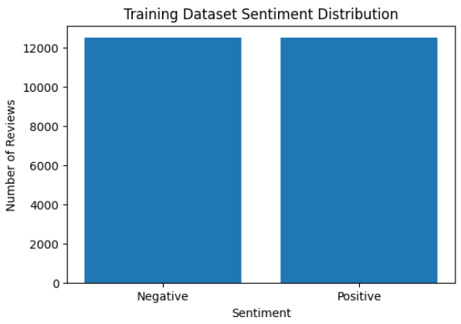
Figure 1. Screenshot from Cell 8, Output 1 — sentiment distribution generated by the submitted notebook.
Screenshot placement: use the chart shown above from Cell 8, Output 1. If the report is regenerated from a fresh run, keep the screenshot from the executed notebook rather than inserting a manually recreated chart.
4. PREPROCESSING
The notebook demonstrates the main preprocessing stages required by the assignment. The built-in IMDB loader already supplies reviews as integer-encoded word sequences. A decoded example is also cleaned by lowercasing, removing HTML-style break tags, removing non-alphabetic characters, and normalizing whitespace. This cleaning demonstration explains the text-cleaning concept while the actual model input continues to use the official integer-encoded IMDB sequences.
4.1 Tokenization / Integer Encoding
The tokenization cell displays the first 50 integer IDs of the first encoded review and identifies its label. In this dataset implementation, the integer sequence is already produced by the Keras IMDB loader. The Embedding layer converts these token IDs into trainable dense representations.
4.2 Padding and Truncation
The notebook applies pad_sequences with maxlen=200, padding='post', and truncating='post'. The executed output reports X_train with shape (25000, 200) and X_test with shape (25000, 200). Thus, every review is represented using exactly 200 positions before entering the recurrent models.
Screenshot placement: Cell 10, Output 0 contains the decoded/cleaned review demonstration; Cell 12, Output 0 contains the tokenized integer sequence; Cell 14, Output 0 contains the padding shape and padded sequence. For a compact 3–5 page report, use the screenshot from Cell 14 as the main preprocessing evidence and optionally use Cell 10 for the cleaning evidence.

5. MODEL ARCHITECTURES
All three models share the same overall input/output structure: an Embedding layer receives integer token IDs, the recurrent layer processes the sequence, and a Dense layer with sigmoid activation produces a binary sentiment probability. The main difference is the recurrent layer.
5.1 Simple RNN
The RNN model is defined as Embedding(input_dim=10000, output_dim=128), followed by SimpleRNN(64), followed by Dense(1, activation='sigmoid'). It provides the baseline recurrent architecture. The model is trained for five epochs with batch size 64, using Adam and binary cross-entropy.
Screenshot placement: Cell 16 contains the RNN model-summary outputs. Use the complete model-summary output from Cell 16 as the RNN architecture screenshot if your instructor expects code-output evidence.
5.2 LSTM
The LSTM model uses the same embedding and output structure but replaces SimpleRNN with LSTM(64). The gating mechanism is designed to control information retention and updating across the sequence. The notebook trains the LSTM using exactly the same main training settings.
Screenshot placement: Cell 22 contains the LSTM model-summary outputs. Use this output as the LSTM architecture screenshot.
5.3 GRU
The GRU model uses the same embedding and output structure with GRU(64) as the recurrent layer. It uses a gated recurrent mechanism with a simpler structure than LSTM. The notebook again uses the same batch size, epoch count, optimizer, and loss.
Screenshot placement: Cell 26 contains the GRU model-summary outputs. Use this output as the GRU architecture screenshot.
6. TRAINING CONFIGURATION
Parameter | Notebook value
Vocabulary size | 10,000
Maximum sequence length | 200
Embedding dimension | 128
Recurrent units | 64
Batch size | 64
Epochs | 5
Optimizer | Adam
Loss | Binary cross-entropy
Validation split | 20%
Table 1. Training and preprocessing settings taken from the submitted notebook.
7. EXPERIMENTAL RESULTS
The following values are taken directly from the executed outputs stored in the submitted notebook. The final comparison cell reports percentages for the four classification metrics and seconds for training time.
Model | Accuracy | Precision | Recall | F1-score | Training Time
RNN | 50.50% | 50.41% | 62.28% | 55.72% | 164.96 s
LSTM | 81.01% | 90.12% | 69.65% | 78.57% | 412.39 s
GRU | 84.38% | 83.79% | 85.26% | 84.52% | 616.33 s
Table 2. Final comparison table reproduced from Cell 30, Output 1 of the executed notebook.
The RNN achieved the lowest training time at 164.96 seconds, but its accuracy was only 50.50% and its F1-score was 55.72%. LSTM improved the classification results substantially, reaching 81.01% accuracy and 78.57% F1-score, with a training time of 412.39 seconds. GRU achieved the highest measured accuracy (84.38%), recall (85.26%), and F1-score (84.52%) in this run, but also required the longest training time at 616.33 seconds.
The final automated-analysis cell in the notebook explicitly identifies GRU as the model with the highest measured F1-score and RNN as the fastest training model. This conclusion is based on the stored execution results rather than assumed benchmark values.
7.1 Classification Reports
The classification reports provide class-level precision, recall, F1-score, and support. Each test set contains 12,500 negative and 12,500 positive reviews. The RNN report shows weaker and less balanced performance. The LSTM report shows a strong precision value for the positive class but a lower positive-class recall. The GRU report shows approximately balanced class-level performance, with 0.85 positive-class recall and 0.84 negative-class recall.

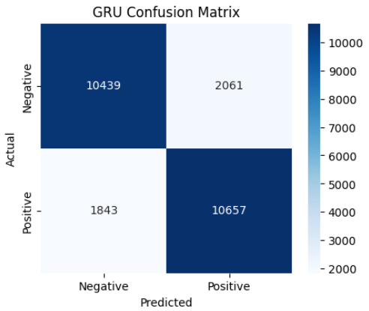
Figure 2. Screenshot from Cell 28, Output 1 — GRU classification report and confusion matrix.
8. CONFUSION MATRIX ANALYSIS
A confusion matrix provides a class-level view of correct and incorrect predictions. The notebook generates a confusion matrix immediately after each classification report. These screenshots are useful evidence for the report because they demonstrate that the models were actually evaluated on the 25,000-review test set.

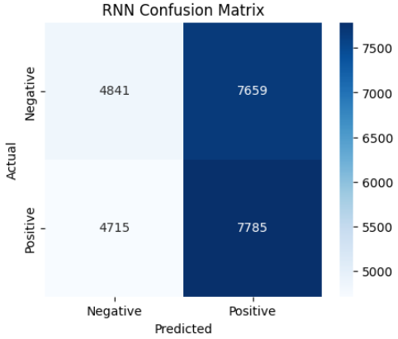
Figure 3. Screenshot from Cell 20, Output 1 — RNN confusion matrix.

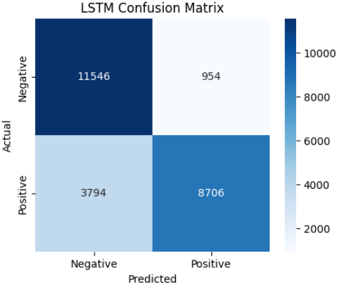
Figure 4. Screenshot from Cell 24, Output 1 — LSTM confusion matrix.
Figure 5. Screenshot from Cell 28, Output 1 — GRU confusion matrix.
Screenshot placement instruction: if page space is limited, use only the GRU confusion matrix in the final 3–5 page report because the numerical comparison table already summarizes all three models. If a detailed appendix is allowed, include all three confusion matrices.
9. PERFORMANCE VISUALIZATION
The notebook generates four visualization outputs: a combined classification-metric comparison, training-time comparison, training/validation accuracy curves, and training/validation loss curves. These figures should be retained as screenshots from the executed notebook so that the report remains traceable to the submitted implementation.
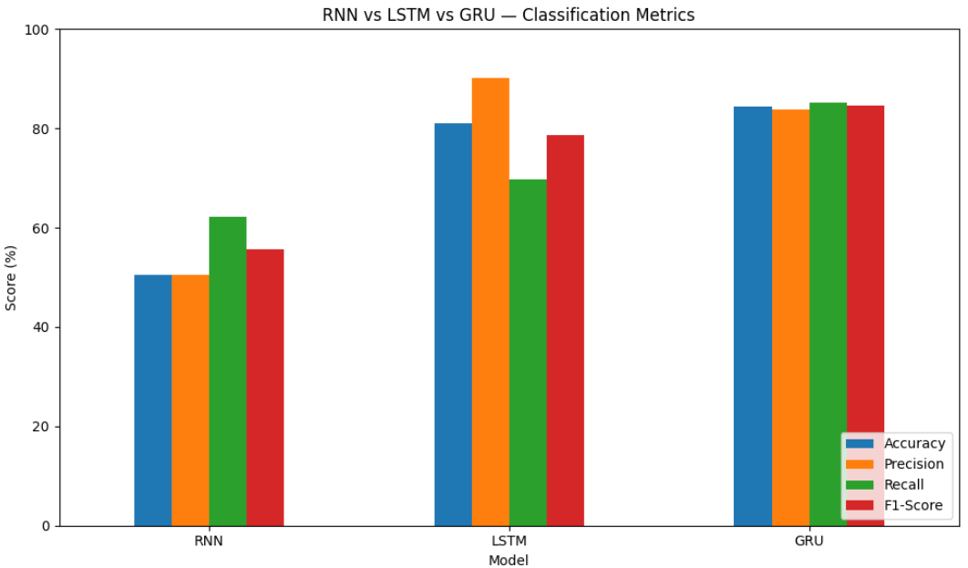
Figure 6. Screenshot from Cell 33, Output 0 — Accuracy, Precision, Recall, and F1-score comparison.

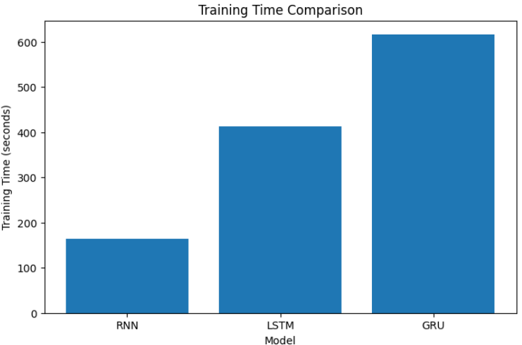
Figure 7. Screenshot from Cell 34, Output 0 — training-time comparison.

10. LEARNING CURVES
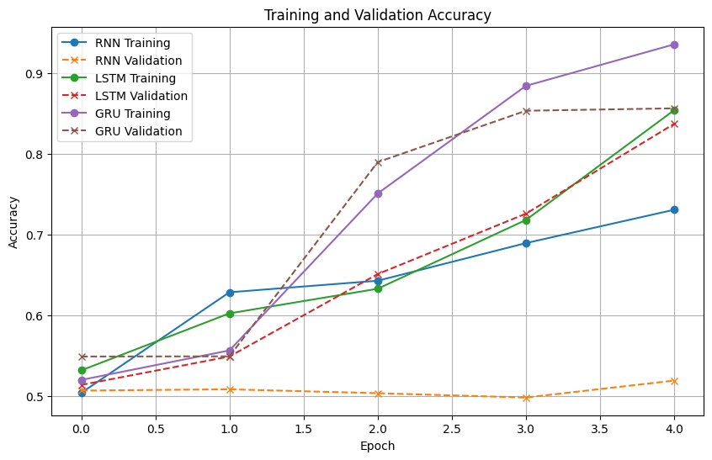
Figure 8. Screenshot from Cell 36, Output 0 — training and validation accuracy curves.
The accuracy curves show how the three models behaved across the five training epochs. The exact curve shapes should be interpreted together with the final test-set metrics because validation accuracy and test accuracy measure performance on different evaluation subsets.
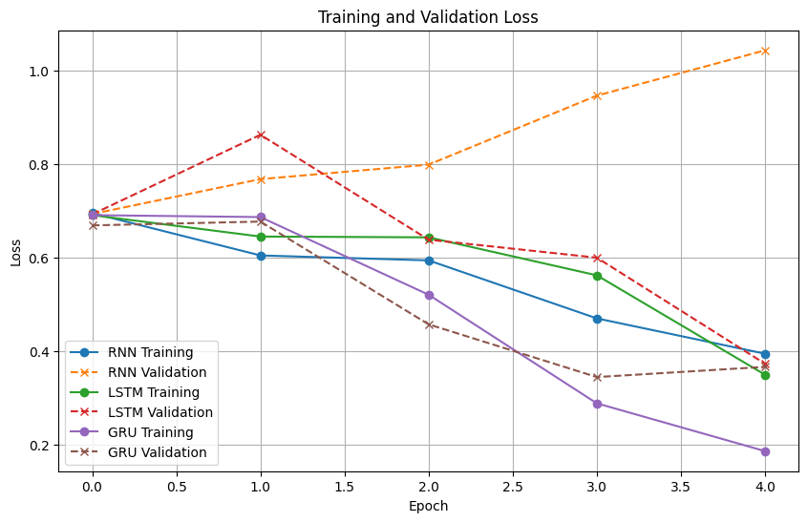
Figure 9. Screenshot from Cell 38, Output 0 — training and validation loss curves.
The loss curves provide additional evidence about learning behaviour. A widening gap between training and validation loss can indicate overfitting, while consistently high loss may indicate insufficient learning. In this experiment, the curves should be read together with the final classification metrics rather than treated as a standalone ranking.
11. DISCUSSION
The measured results show a clear difference between the three recurrent architectures under the selected configuration. SimpleRNN required the least training time, but its test performance remained close to the level of a weak binary classifier. Its 50.50% accuracy and 55.72% F1-score indicate that the basic recurrent architecture did not learn the sentiment task as effectively as the gated architectures in this particular five-epoch experiment.
LSTM produced a substantial improvement over SimpleRNN. Its accuracy increased to 81.01%, precision reached 90.12%, recall reached 69.65%, and F1-score reached 78.57%. The results show that LSTM was capable of learning useful sequential representations, although its precision and recall were not as balanced as those obtained by GRU in this run.
GRU produced the highest measured accuracy and F1-score: 84.38% and 84.52%, respectively. Its precision was 83.79% and recall was 85.26%, giving a comparatively balanced result between the two measures. However, GRU required 616.33 seconds, which was the longest training time among the three models. Therefore, the experimental results demonstrate a performance-versus-training-time trade-off: the model with the strongest measured classification result was not the fastest model.
It is important to treat these conclusions as specific to the executed notebook configuration. The experiment uses five epochs, a maximum sequence length of 200, a 10,000-word vocabulary, and 64 recurrent units. Different hyperparameters, hardware, random seeds, or training durations can change the measured values.
12. CONCLUSION
This experiment successfully implemented and evaluated SimpleRNN, LSTM, and GRU models for binary sentiment classification on the built-in IMDB dataset. The same preprocessing and main training settings were used for all three architectures, and the required metrics were calculated on the test set.
From the executed results, GRU achieved the highest accuracy (84.38%) and F1-score (84.52%), while RNN had the lowest training time (164.96 seconds). LSTM occupied an intermediate position in both predictive performance and training cost. The results therefore illustrate the practical trade-off between recurrent-model complexity, predictive performance, and computation time. The report's conclusions are based directly on the values recorded in the submitted notebook.

